Contact Us

Communication

1. Change mail id to info@4mpacks.com

2.
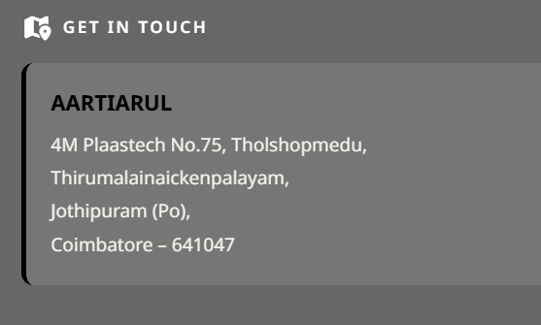 Change AARTIARUL to Ganesh Kumar K

3. GET QUOTE
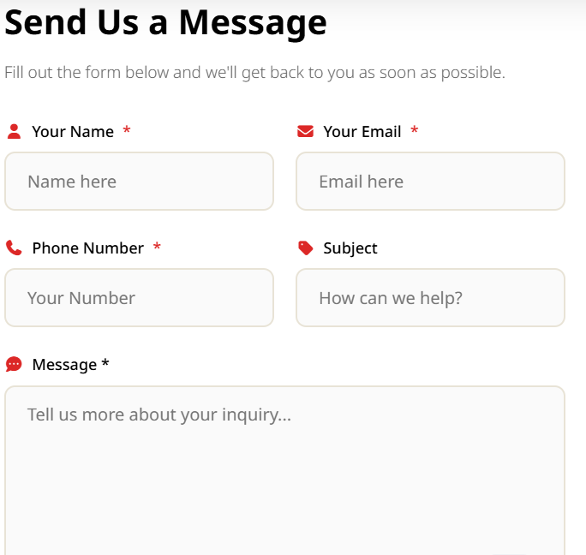
I filled out this form and submitted just to check, but the below error screen only came.

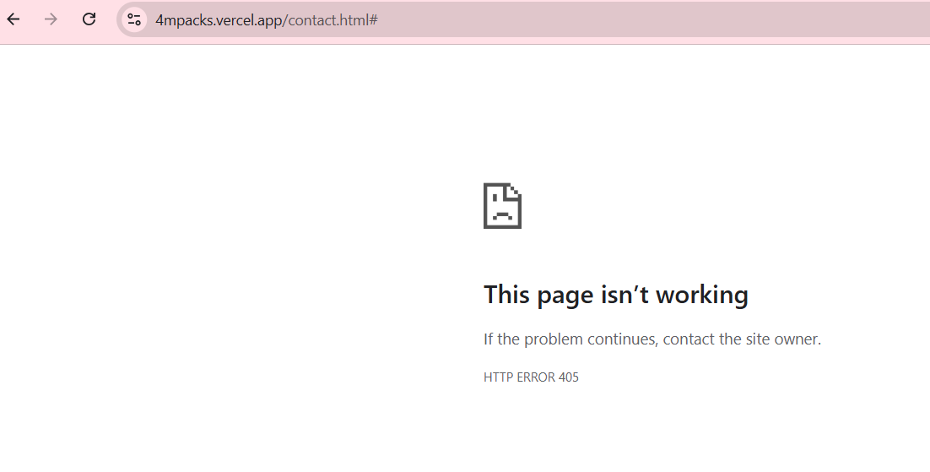

4. Engineering Products

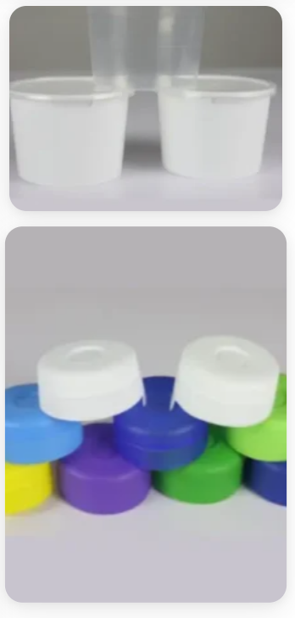 Remove these two pictures from this page and align the image sizes evenly.

5.

When clicked on Twitter icon, its going to Instagram.
When clicked on Linkedin, its just going to the same website.

